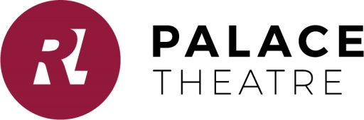
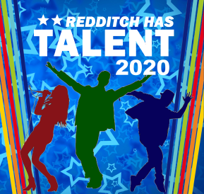
Redditch Has Talent Auditions 2020 Form A2 18 years & over
(Complete a form for each person if in a duet or group) Email recording and application from to RHTpalace@gmail.com or submit to Palace Theatre Box Office c/o Maria Brannelly

Full Name
I am over 18 years old or over Y/N if ‘No’ complete form C1
Address
Postcode
Contact details – these will be used to arrange audition
Mobile
Email

Type of act
Name of Act (If you have one)
State number of people in act
Age of youngest performer
In the first instance entry is by recording, preferably video clip – mobile phone footage is fine! Minimum length 30 seconds. We will only watch the first 5 minutes of any clip sent. No audio editing or effects are permitted. Only one recording per act.
Video attached Y/N ________________________________________

I am applying to be auditioned for Redditch Has Talent and, if successful, confirm that I am available to perform at the RHT 2020 Final at the Palace Theatre on 2 July.

Signed Date

Auditioning for RHT 2020 couldn’t be simpler. Act now before applications close on 28th February 2020. Send in a recording of your act with the application form (new streamlined version for schools and large groups). Minimum length 30 seconds. We will only watch the first 5 minutes of any clip sent. Mobile phone footage is fine! No audio editing or effects are permitted. Only one recording per act.
Successful applicants will be called to the live auditions held at the Palace Theatre Studio in March 2020, where we will select our finalists for the Redditch has Talent 2020 Final on 2 July.
Please note: the piece you perform at live auditions will be the piece performed at the Final.
Email recording and application from to RHTpalace@gmail.com or submit to Palace Theatre Box Office or send to:
RHT Auditions,
C/O Maria Brannelly,
Palace Theatre,
Alcester Street,
Redditch.
B98 8AE
The judge’s decisions are final and no discussions or correspondence concerning such decision may ensue.

